
SVKM’s INSTITUTE OF TECHNOLOGY, DHULE
Department of Information Technology
Academic Year 2025-26

Experiment 6

Name: Bhupesh Anil Suryawanshi
Roll No.: 63
Batch: B3

Aim: To implement Fuzzy Membership Functions (triangular, trapezoidal, gbell, PI, Gamma, Gaussian)

Theory :

Membership function :

In fuzzy logic, a membership function (MF) defines how each point in the input space is mapped to a membership value (degree of belonging) between 0 and 1. This value represents the degree of truth that an element belongs to a fuzzy set.

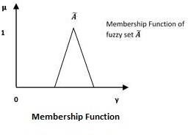
Membership function represents the degree of truth in fuzzy logic.
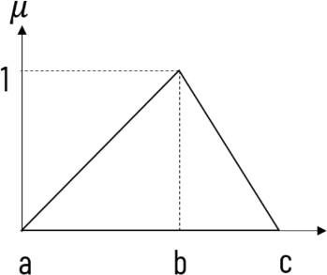

• Membership functions were first introduced in 1965 by Lotfi A. Zadeh in his first research paper "Fuzzy Sets".
• Membership functions characterize fuzziness (i.e., all the information in fuzzy set), whether the elements in fuzzy sets are discrete or continuous.
• Membership functions can be defined as a technique to solve practical problems by experience rather than knowledge.
• Membership functions are represented by graphical forms.
• Rules for defining fuzziness are fuzzy too.

- Triangular membership function :

This is one of the most widely accepted and used membership functions (MF) in fuzzy controller design.
The triangle, which fuzzifies the input, can be defined by three parameters: a, b, and c,

where :
- a and c define the base of the triangle, and
- b defines the peak (height) of the triangle.

In the diagram, the X-axis represents the input from the process (such as an air conditioner, washing machine, etc.), and the Y-axis represents the corresponding fuzzy value (i.e., the degree of membership ranging from 0 to 1).

• Properties :
- Fast and simple computation.
- Symmetric if bbb is midway between aaa and ccc.
• Applications : Common in control systems (e.g., temperature ranges like cold, warm, hot).
- Triangular MF :
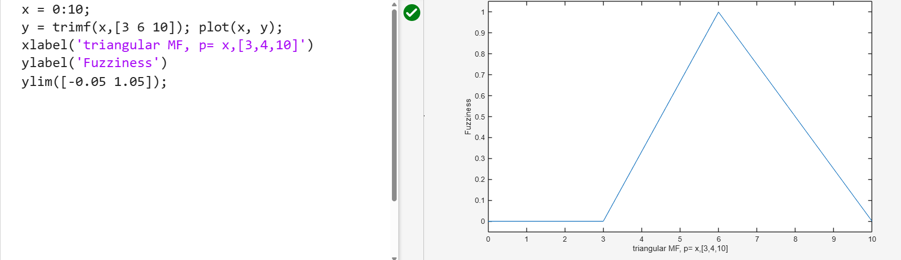

If input x = b, then it is having full membership in the given set. So,

μ(x) = 1, if x = b

And if the input is less than a or greater than c, then it does not belong to the fuzzy set at all, and its membership value will be 0 :

μ(x) = 0, if x < a or x > c
- Trapezoidal membership function :
Trapezoidal membership function is defined by four parameters: a, b, c and d. Span b to c represents the highest membership value that element can take. And if x is between (a, b) or (c, d), then it will have membership value between 0 and 1.
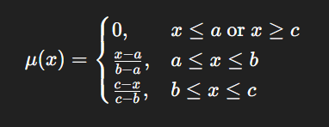
- Equation :
- Parameters of a Trapezoidal Membership Function
- a : The left-most point, where the membership starts to rise from zero.
- b : The left-most point of the top flat part, where the membership reaches one.
- c : The right-most point of the top flat part, where the membership starts to fall from one.
- d : The right-most point, where the membership falls back to zero.
• Properties :
- Includes a flat region of full membership.
- More flexible than triangular.
• Applications : Modeling ranges like safe speed zone, acceptable humidity.
- Trapezoidal MF :
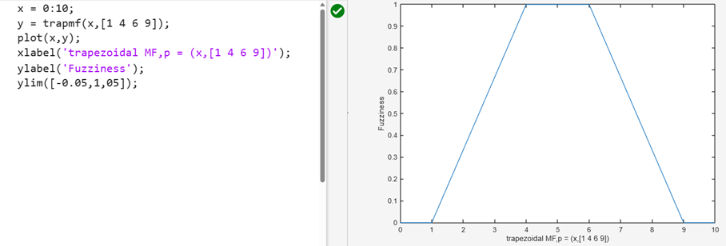
- Gaussian membership function :
A Gaussian MF is specified by two parameters {m, σ} and can be defined as follows.
Where,
• m : Mean (center).
• σ : Standard deviation (width).
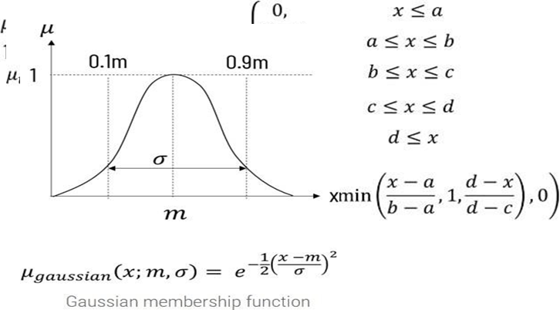
In this function, m represents the mean / centre of the gaussian curve and σ represents the spread of the curve. This is more natural way of representing the data distribution, but due to mathematical complexity it is not much used for fuzzification.
• Properties :
- Smooth, continuous, differentiable.
- Natural representation of uncertainty.
• Applications : Fuzzy clustering , neuro-fuzzy systems, pattern recognition, etc.

Gaussian MF :

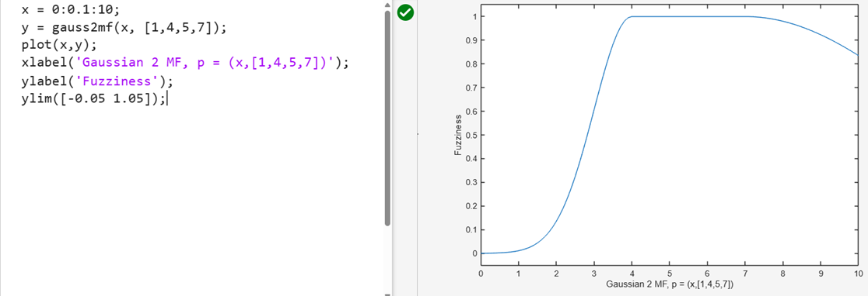

- Gaussian 2 MF :
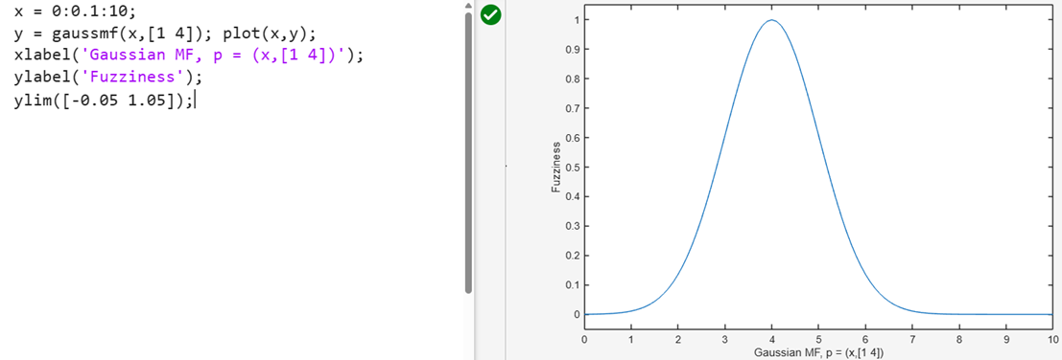

- Bell Membership Function :

The Bell Membership Function is a smooth, bell-shaped curve used in fuzzy logic to represent how strongly a value belongs to a fuzzy set.
It gives values between 0 and 1, showing the degree of membership.
- Bell MF :

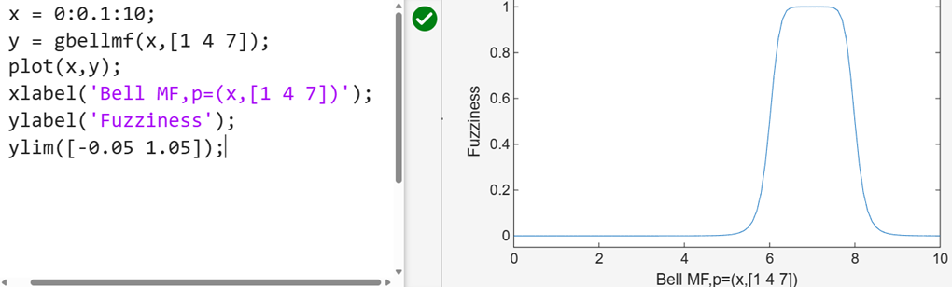
Formula :
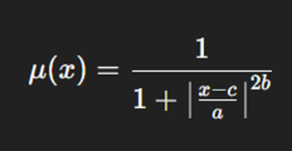
5. Sigmoidal Membership Function :
The Sigmoidal Membership Function is an S-shaped curve used in fuzzy logic to show a gradual transition from non-membership (0) to full membership (1).
It smoothly increases or decreases and is very useful for modeling fuzzy sets like “high,” “low,” or “fast.”

- Sigmoidal MF 1 :
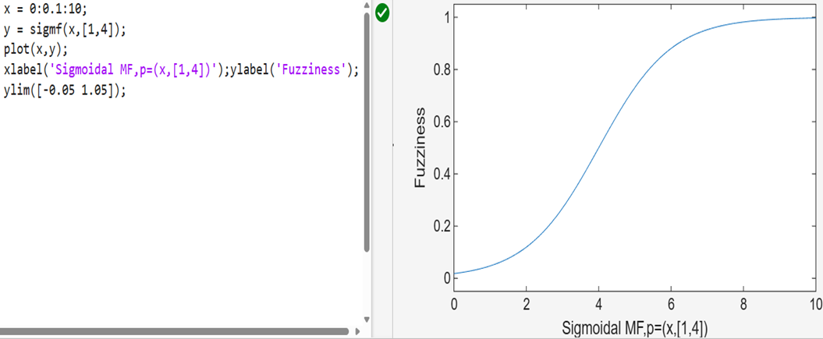
- Sigmoidal MF 2 :

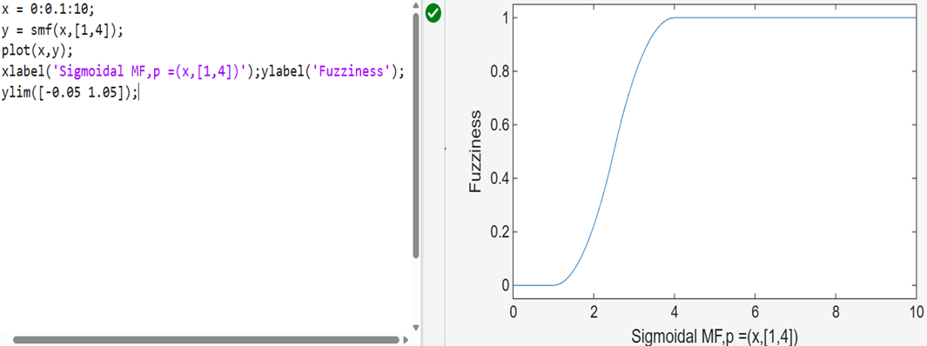
    - Pi-shaped Membership Function :
The Pi-shaped Membership Function (π-MF) is a combination of an S-shaped and a Z-shaped curve, forming a smooth “π” (pi)-shaped structure.
It is used in fuzzy logic to represent fuzzy sets that increase gradually, stay high for a range, and then decrease smoothly again.

- PI MF :

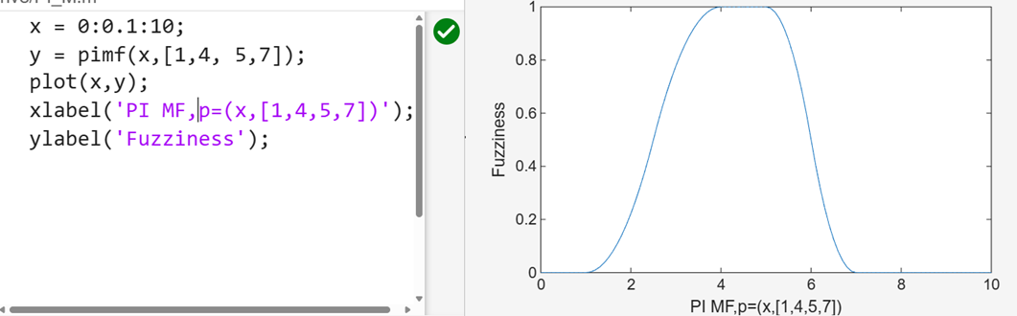
Conclusion :
In this experiment, various fuzzy membership functions such as Triangular, Trapezoidal, Gaussian, Generalized Bell, Sigmoidal, and Pi-shaped were implemented and plotted.
Each function represents how input values belong to a fuzzy set with a degree between 0 and 1.
From the plots, we observed that different membership functions provide different shapes and smoothness for representing fuzziness, helping to model real-world uncertainty effectively in fuzzy logic systems.

